**Spring**

16

**Adaptive Exploration for Geological Classification Final Report**

Team: Aishanou Osha Rait, Shivam Gautam, Tushar Agrawal, and Bishwamoy Sinha Roy

Mentors: Prof. David Wettergreen and Greydon Foil

08

**Fall**

Table of Contents

Introduction 3

Simulation Environment 3

Challenge 1: Where to Sample 4

Approach 1: Differential Entropy 4

Approach 2: Shannon’s Entropy via Clustering 4

Challenge 2: Planning a Path to sampling point 4

Approach 1: Dynamic Programming 4

Approach 2: Multi-Heuristic A* 4

Conclusion 4

# Introduction

Although the Curiosity rover is one of humanity’s greatest achievements, there remains room for improvement. It currently takes a lot of time to send precise waypoints to the rover due to inherent communication latencies. As such, current research methods focus on making rover exploration smarter. One approach is for the rover to pick waypoints in accordance to some optimization variable.

The general problem is of geological classification via noisy spectrometer data. For example, a satellite might survey a region on Mars. This survey will return low resolution and noisy data of the region. Low resolution, in terms of spectroscopy, means the light broken down into a limited, often small, number of wavelengths. Using this data, rock classification is iffy and will have multiple errors. As such, a ground rover is provided with a high-resolution spectrometer. However, using this spectrometer is resource costly, thusly prohibiting continuous sampling. As such, the rover needs to use the noisy data and a certain resource budget to sample in key points so as to provide the cleanest data possible for rock classification.

Information gain is of importance in an information theoretic approach to adaptive exploration. The basic idea is the to choose the key points so as to maximize the information gain from each sample. The whole problem is inherently broken into two challenges. First, the rover needs to select key points, which is a global planner. Second, a local planner needs to plan a path to the key points, during which it can take multiple samples within a certain budget. As such, a plan for the rover not only contains waypoints but also sample points within the path. The project, however, focuses on just coming up the waypoints, assuming rover is sampling at each point.

Lastly, the algorithms were implemented on a simulator not on the actual Zoe rover.

# Simulation Environment

There are three main pieces of information critical to the process. First, the satellite survey from which key points are selected. The satellite image is approximated in simulation by a 2D map, where each point is **s** dimensional vector of intensities at each wavelength. Note, the satellite image can see **s** wavelengths. Second, the data acquired by the rover upon using its more expensive and higher resolution spectrometer. This data is approximated by another 2D map, in which each point holds an **n** dimensional vector. Note, since the rover’s spectrometer is high resolution, **n > s.** When the rover samples, the sample is pulled from the second map. In simulation both maps are provided to the rover, the first to plan in, and the second to pull samples from. Lastly, a true classification is also gleamed from the simulator, which isn’t used by the rover. We can choose the number of distinct rock classes present in the image and also a number of dominant and rare classes. Figure 1, shows the three maps. In this figure, only the first 3 channels of the second map are shown as an image. Observed values map is the satellite map, while the true values map is the second sample map.

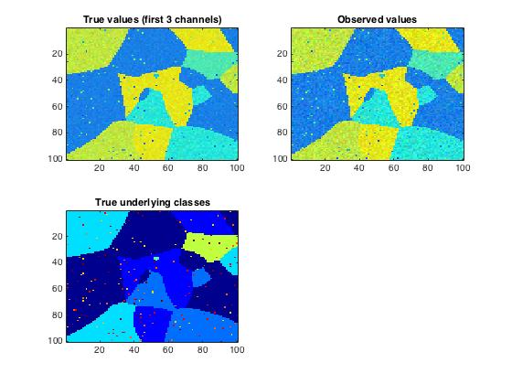

Figure : Simulation Maps (s = 3, n = 8, dominant classes = 8, rare classes = 2, total classes = 10)

# Challenge 1: Where to Sample

## Approach 1: Differential Entropy

## Approach 2: Shannon’s Entropy via Clustering

The information theoretic approach to choosing a point to sample basically tries to optimize the amount of information gained by sampling, which is akin to decreasing “uncertainty” by the largest amount. To do this, we sample at the point that has the highest uncertainty. One way to formulate uncertainty was mentioned via differential entropy. Another way is using traditional Shannon’s entropy, which is the expected information of a probability distribution. We defined the probability distribution over a set of discrete classes. Each class was defined by clustering the satellite image in feature space. Each wavelength in the satellite spectroscopic map was taken to be a feature. The data seems to be pulled from a mixture of Gaussian. Finding the cluster centers then is a Gaussian process.

We applied k-means and meanshift to find cluster centers. Since k-means is a parametric approach, we assumed the number of distinct classes of rocks in the map was known. On the other hand, meanshift doesn’t assume number of classes but requires a variable called ‘bandwidth’ to be defined, which is basically how big the clusters should be in feature space, a variable that can be optimized. In a particular region, there exists two types of classes, dominant and rare classes. Since there are little points pulled from the rare classes, the classification via clustering will never find the rare class’ cluster center.

|  |  |
| --- | --- |
| Equation 1 | $$P_{ij}=\frac{1/{d_{ij}}}{\sum_{j=1}^{J}{1/{d_{ij}}}}$$ |
| Equation 2 | $$H\left(i\right)= \sum_{j=1}^{J}{P_{ij}\log_{2}(\frac{1}{P_{ij}})}$$ |

Once the cluster centers are found, equation 1 is used to define a probability a point ‘**i**’ falls within cluster ‘**j**’ using the Euclidean distance, which ought to be modified to mahalnobis distance for appropriate use. Using this probability, shannon’s entropy is calculated using equation 2. Once the entropy is defined, the maximum entropy point is sampled. Sampling means pulling the spectrometer reading from the rover sample map (info 2 described in the simulation environment section). This moves the point in feature space because the true value of the point is now available. A Gaussian kernel is defined around the moved point to move nearby points. The standard deviation of the Gaussian kernel is proportional to the distance of the moved point to its cluster center. Basically, points that are very close to a cluster will create a larger Gaussian kernel. Without re-clustering, the equations are used to create an updated entropy map, from which a new sampling point is selected.

The algorithm was run on a test data of 10 different maps. The number of dominant and rare classes was varied, while keeping the total number of classes constant. Additionally, the probability of being picked from rare classes is varied as well. The results shown are very unstable. Although the entropy decreases by 1.25% for k-means and 2.96% in meanshift respectively, as seen in the figures, the drop is very erratic.

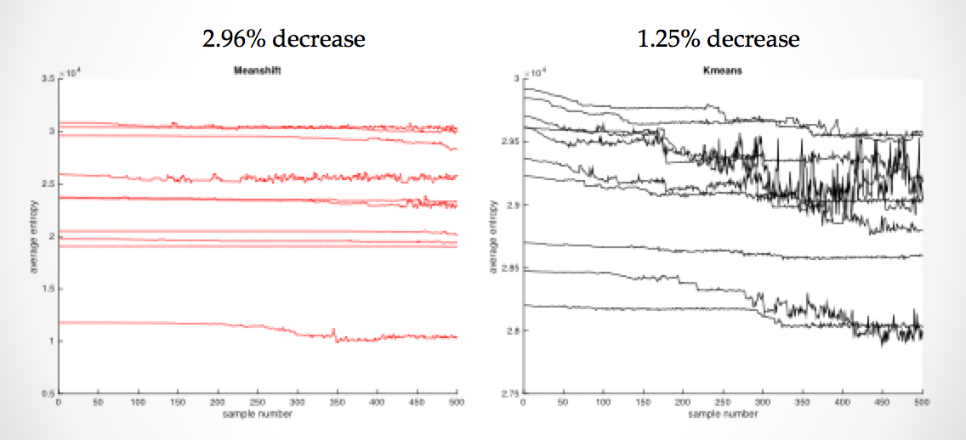

Figure : Average entropy from 10 test maps

# Challenge 2: Planning a Path to sampling point

## Approach 1: Dynamic Programming

## Approach 2: Multi-Heuristic A*

# Conclusion